**Project Design Phase-II**

**Data Flow Diagram & User Stories**

|  |  |
| --- | --- |
| Date | 28-06-2025 |
| Team ID | LTVIP2025TMID46195 |
| Project Name | BookNest |
| Maximum Marks | 4 Marks |

**Data Flow Diagrams:**

A Data Flow Diagram (DFD) illustrates how data flows within the BookNest platform. It shows interactions between users (readers, authors, and admins), system components, and data storage.  
  
Example: DFD Level 0 (Industry Standard)  
  
- Readers can browse, search, and purchase books.  
- Authors can upload and manage book listings.  
- Admins moderate content and manage platform operations.  
- System handles authentication, book listings, reviews, and payment transactions.  
- Data Stores include user profiles, book inventory, orders, and messages.

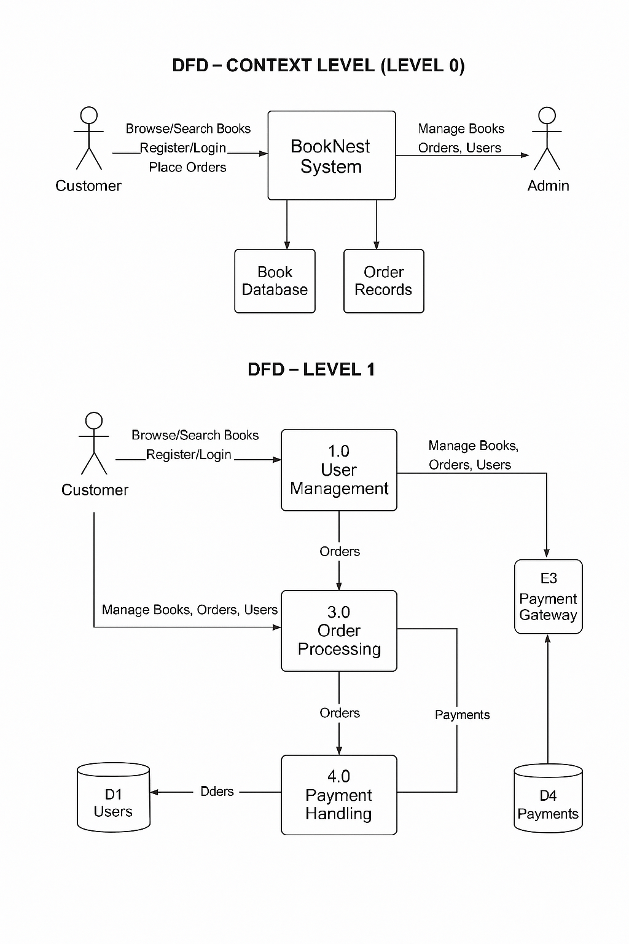

## User Stories

User Story Table – BookNest

|  |  |  |  |  |  |
| --- | --- | --- | --- | --- | --- |
| **User Type** | **Functional Requirement (Epic)** | **User Story / Task** | **Acceptance Criteria** | **Priority** | **Release** |
| Reader | Book Discovery | As a reader, I can search for books by title, author, or genre. | Search returns relevant book listings. | High | Sprint-1 |
| Reader | Purchase System | As a reader, I can purchase e-books securely. | Payment is processed and download is available. | High | Sprint-2 |
| Author | Book Management | As an author, I can upload and manage my book listings. | Books are visible to readers after submission. | High | Sprint-1 |
| Author | Earnings Dashboard | As an author, I can view sales and earnings reports. | Dashboard displays up-to-date metrics. | Medium | Sprint-2 |
| Admin | Content Moderation | As an admin, I can review and remove inappropriate content or books. | Flagged content is reviewed and actioned. | High | Sprint-1 |
| Reader & Author | Messaging | As a user, I can send and receive messages with other users. | Messages appear instantly and are stored. | Medium | Sprint-2 |
| Reader | Review System | As a reader, I can leave reviews for purchased books. | Reviews appear on the book’s page. | Medium | Sprint-2 |
| Admin | User Management | As an admin, I can deactivate or flag users violating policies. | Actions are logged and users restricted accordingly. | High | Sprint-1 |